**UML Use Case Diagram**

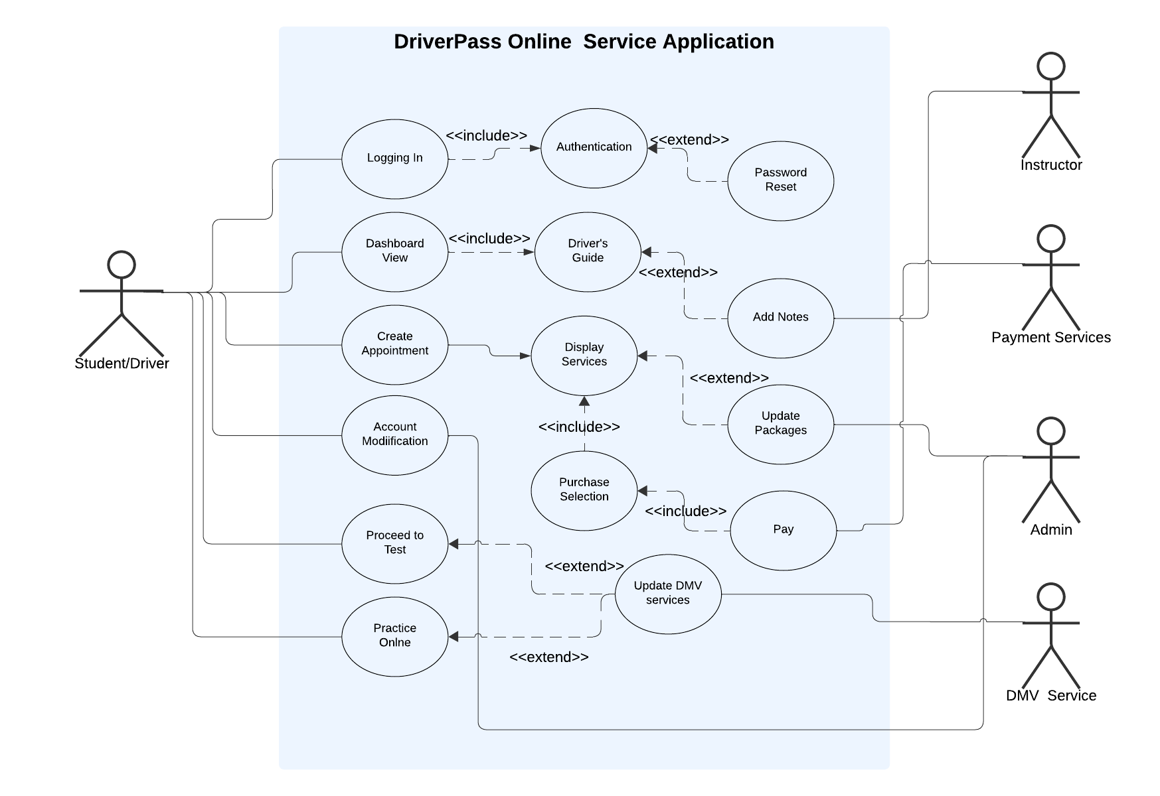

**UML Activity Diagrams**

|  |  |
| --- | --- |
| **Logging In to DriverPass Application** | **Selection of Services to be purchase** |
|  |  |

**UML Sequence Diagram**

|  |
| --- |
| *Selecting a Service to Purchase* |
|  |

**UML Class Diagram**

|  |
| --- |
| *Selecting a Service to Purchase* |
|  |

**Technical Requirements**

The DriverPass app needs a hosting service to run the web app. Users will use their web browsers to access it. A third party should handle the hosting so that the DriverPass doesn’t have to manage the servers. The app needs a customer database with account info and a login system to verify users. It also needs a payment service to take payments from customers. Additionally, it needs access to the DMV to update laws and driver requirements.